Objective Questions:

- What is the total no. of tables present in the data?
Ans. 1
- What is the total no. of attributes present in the data?
Ans. 35
- The data consists of some inconsistent and missing values so ensure that the data used for further analysis is cleaned.
Ans. The data consists of some inconsistent and missing values so ensure that the data used for further analysis is cleaned. The dataset was already in good shape and did not require any manual filling or removal of missing values. I checked all of the accessible columns and deleted those that were absolutely unrelated to the analysis and not used in any questions, charts, or insights.
  - Columns used in the analysis:
    - user, chatStatus, guru, guruName, gid, uid, consultationType, website, chatSeconds, CallDate, callStatus, CallSid, amount, astrologerCallStatus, astrologerOnCallDuration, astrologersEarnings, netAmount, region, userOnCallDuration, rating, createdAT
  - Columns removed (not used at all):
    - _id, refundStatus, isWhiteListUser, queue, freeCall, freeChat, statementEntryId, timeDuration, updatedAt, callChannel, chatStartTime, chatEndTime
  - All other remaining columns were reviewed and found to have no impact on the current analysis, so no further cleaning was required.
- What is the change in daily call volume day by day and also find the average daily call volume.
Ans. Average daily call volume = 246.0294118
Reference- =AVERAGE(B2:B35)
Daily call volume day by day-
- The pivot table shows the number of calls per day, using CallSid (I did in pivot sheet: avgdailycall).
- The day-over-day change in call volume is calculated in a separate column beside the daily count.
- Average Daily Call Volume: 246.03 calls/day
Reference - =AVERAGE(B2:B35)
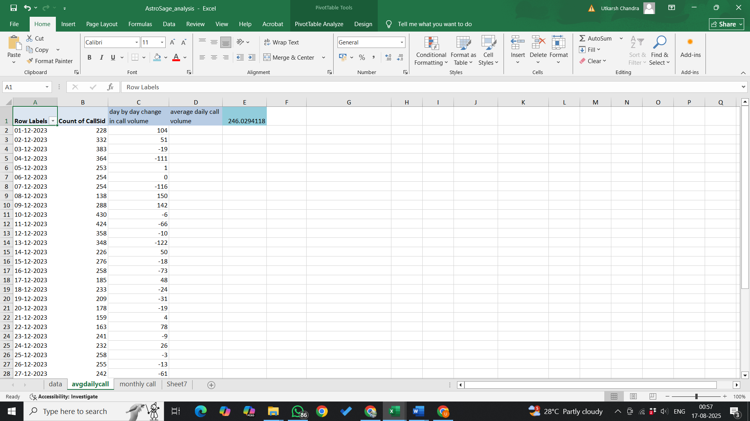

- Which months experienced the highest and lowest call volumes?

- The highest call volume was in December, with 7947 calls.
- The lowest call volume was in January, with 418 calls.
- This was identified using a Pivot Table grouped by Months on the CallDate field.

- What is the total operational cost for that month?

Approach:
- Added Sum of astrologersEarnings to the Values section to calculate the total earnings paid to astrologers.
- In the Filters section, selected all consultation types to include all call and chat-based consultations.
- The total astrologersEarnings was treated as the operational cost for each month.
Observations:
- January: ₹5,360.40
- December: ₹93,786.17
Insights:
- January’s operational cost is significantly lower compared to December.
- The major reason for this difference is the limited number of active days in January within the dataset, resulting in fewer consultations and reduced payouts to astrologers.

- What is the average number of calls handled per agent per day?
Total Calls: 8365
- Unique Agents: 150
- Active Days: 34
- Average = 8365 ÷ (150 × 34) = 1.64 calls/day/agent

- How many repeat callers are there, and what percentage of total calls do they represent?

- Total Calls : 8508
- Repeat calls : 6156
- Total callers count : 3629
- Repeat callers : 1277
- One time call : 2352
- Repeat call % over total calls: 57.35%

- What are the total sales generated by the call centre for each product category?
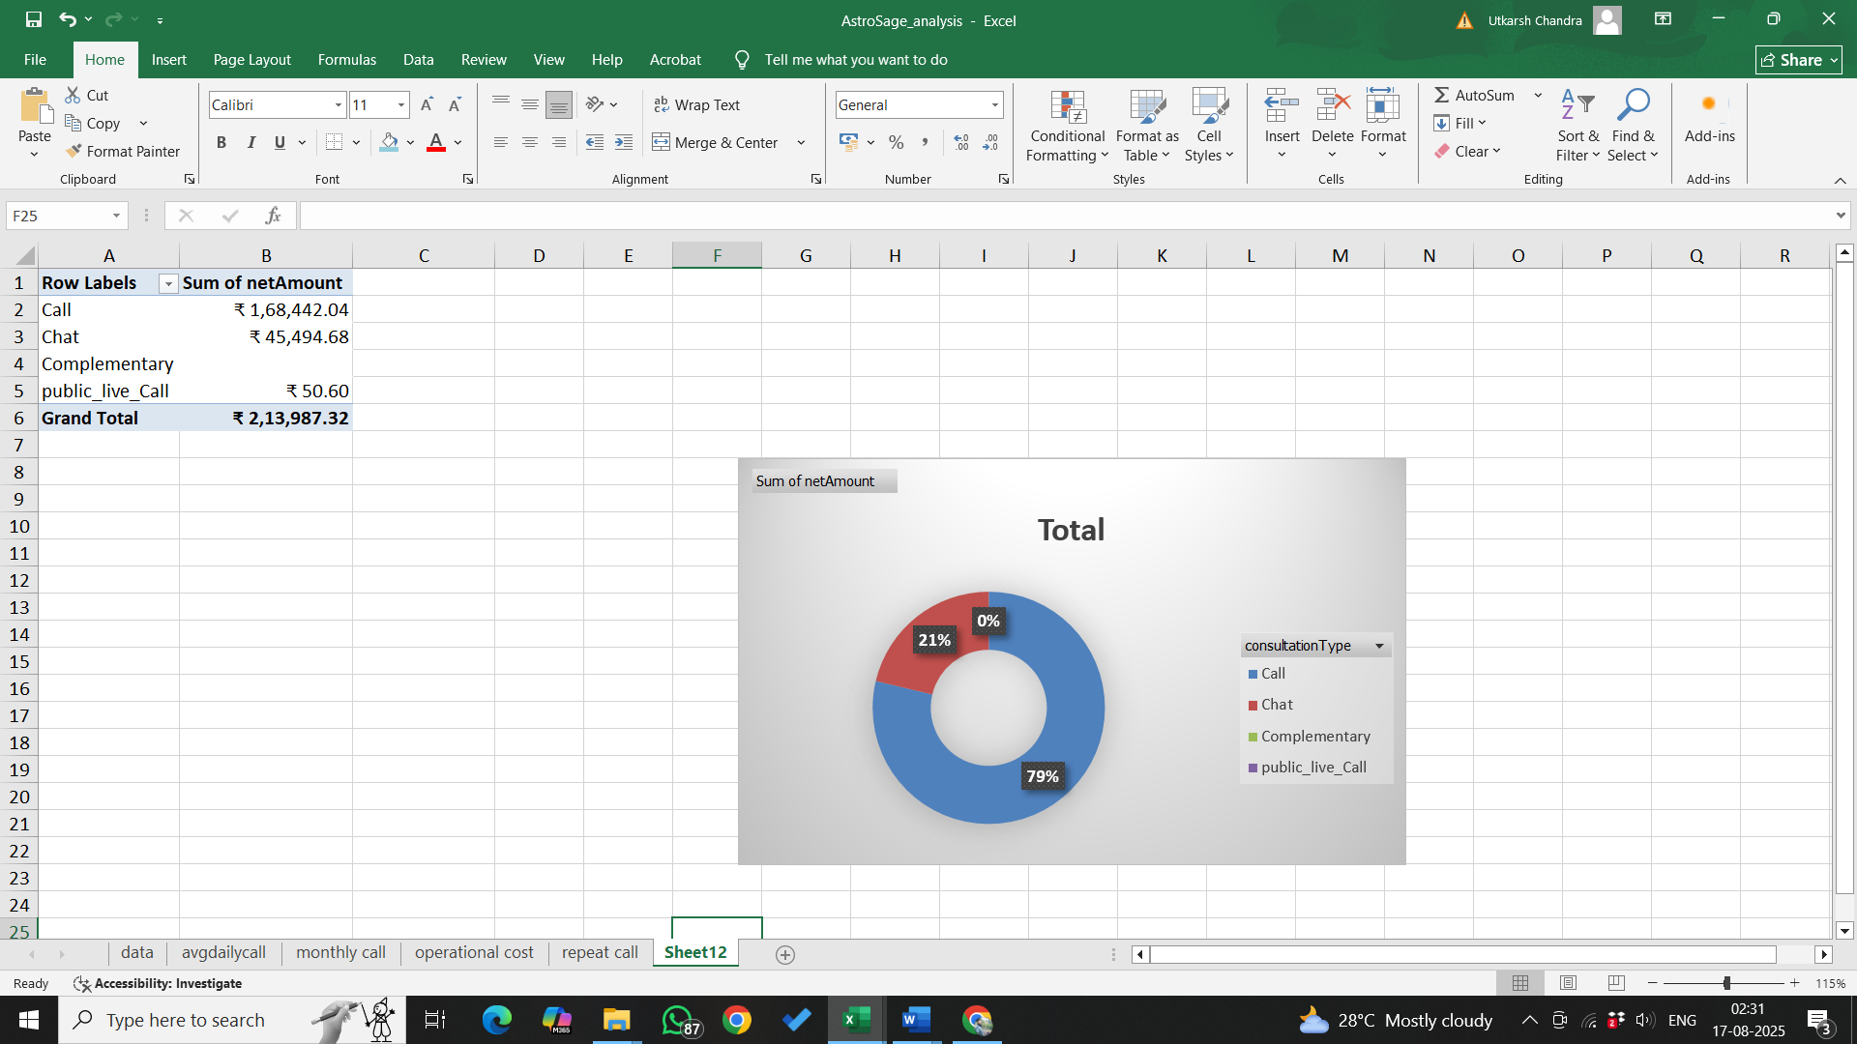 
Observations:
- Call: ₹1,68,442.04 — the major revenue contributor.
- Chat: ₹45,494.68 — secondary source of revenue.
- Complementary: ₹0 — Free Call & Free Chat provided free of charge, no revenue generated.
- Public Live Call: ₹50.60 — negligible revenue contribution.
- Grand Total Sales: ₹2,13,987,32

- How many calls were made for each user ID and guru ID?
USER ID GURU ID
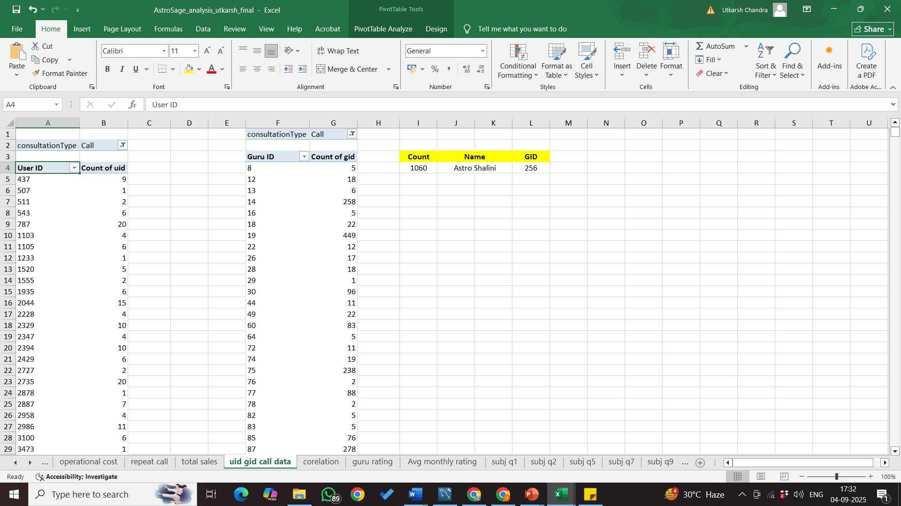


11. What is the correlation between call duration and customer satisfaction?
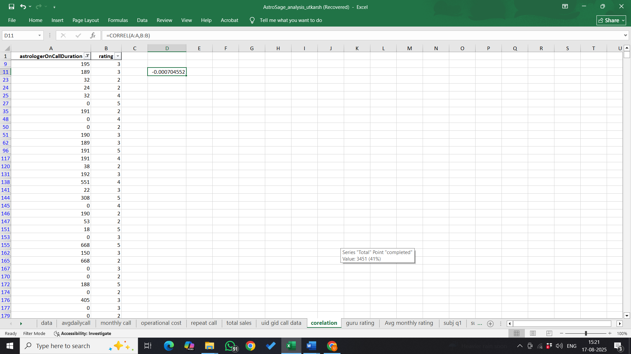
Approach:
  - Applied a filter on the dataset to exclude “Chat” consultation type, ensuring only call-related records were considered.
  - Used Excel’s CORREL function to calculate the statistical correlation between Call Duration and Customer Satisfaction Rating.
Observation:
- The calculated correlation coefficient is 0.0007, which falls in the range of 0.0–0.1, indicating no meaningful correlation between call duration and customer satisfaction.
- This suggests that longer calls do not necessarily result in higher ratings, nor do shorter calls automatically lead to lower satisfaction.

- Which guru has the highest and lowest customer satisfaction scores?
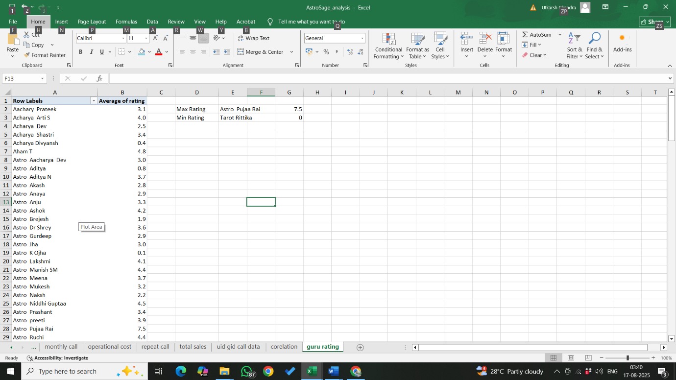
Approach:
- Created a Pivot Table with:
  - Rows: Guru Name
  - Values: Average of Rating (to calculate each guru’s average rating).
Used index match function to find which guru got the :
Maximum - =INDEX(A2:A151,MATCH(MAX(B2:B151),B2:B151,0))
Minimum - =INDEX(A2:A151,MATCH(MIN(B2:B151),B2:B151,0))
Insights:
It has been observed that maximum rating has been given to Astro Pujaa Rai with 7.5 and minimum rating has been given to Tarot Ritika with 0.0.

- What is the average customer satisfaction score by month?

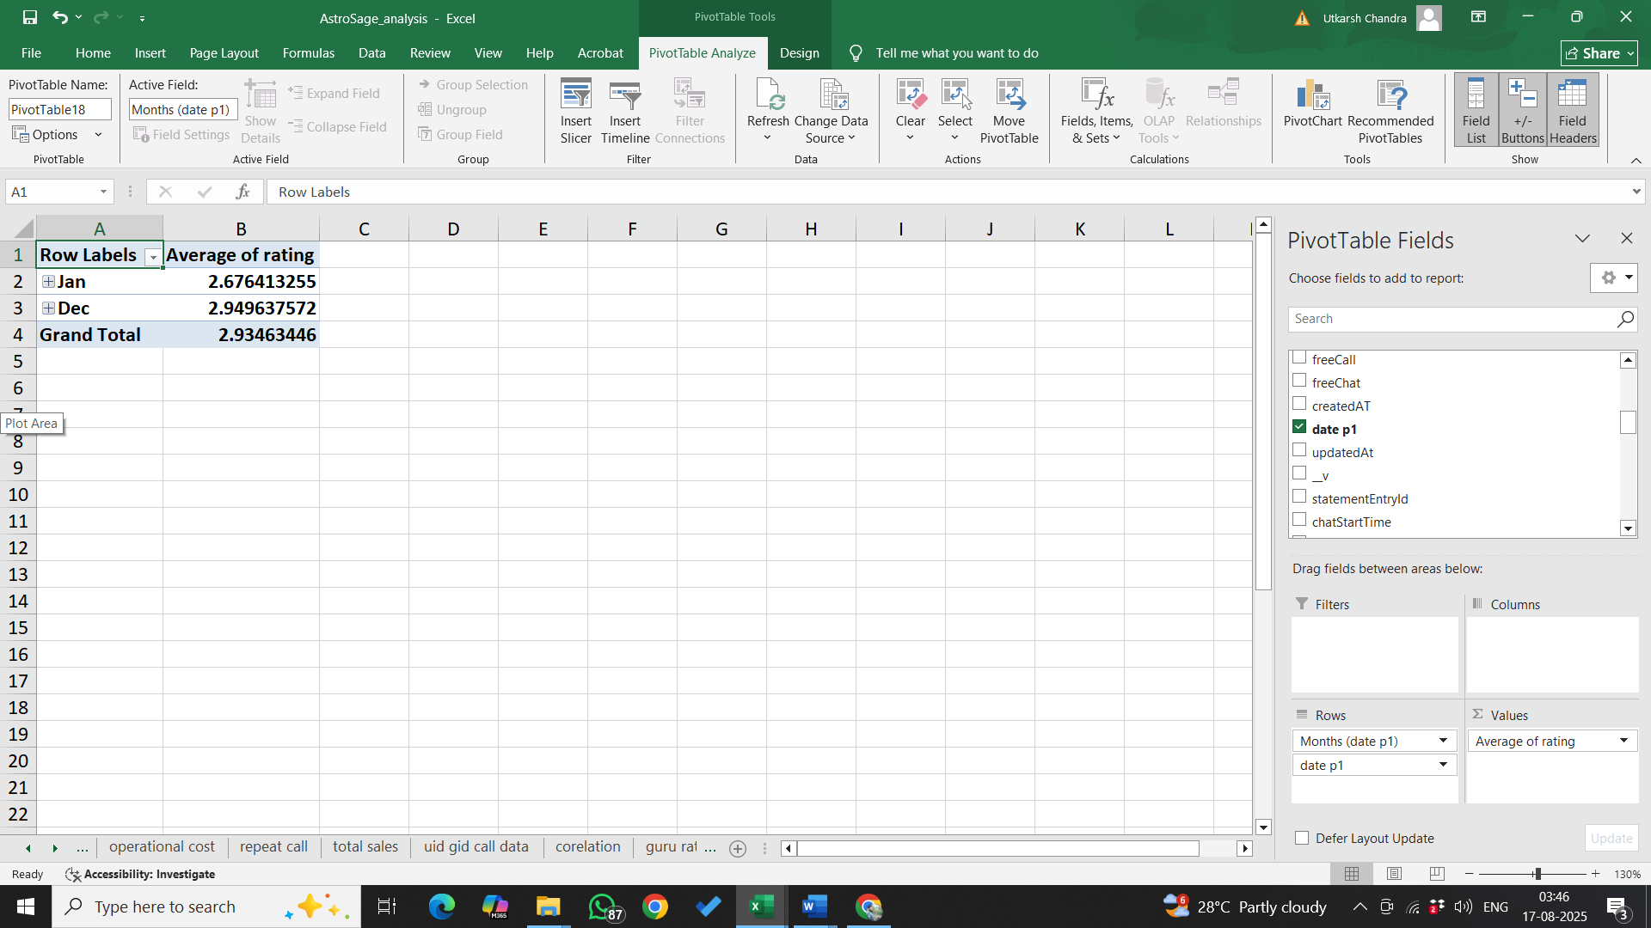
Approach:
- Created a Pivot Table with:
  - Rows: Month
  - Values: Average of Rating (to calculate the mean score for each month).
- Used the Pivot Table to compare January and December ratings directly.
Observation:
- January: 2.68
- December: 2.95
- Both months have scores below 3.0, indicating low overall satisfaction.

- How many categorical columns are there in the data? [Search about categorical and continuous
data, and try to answer this question]
Approach:
- Reviewed the dataset containing 44 columns in total.
- Identified categorical columns based on data types object (string/text) and bool (True/False values).
- Classified these fields as qualitative variables representing statuses, names, flags, or time-based labels rather than numeric measures.
Observation:
- Object-type categorical columns: _id, user, chatStatus, guru, guruName, gid, uid, consultationType, website, Type of User, refundStatus, createdAT, updatedAt, statementEntryId, chatStartTime, chatEndTime, timeDuration, Day, Month, Date, Time, RechatStartTime, RechatEndTime, RetimeDuration, callChannel, callIvrType, callStatus, CallSid, astrologerCallStatus, region, userCallStatus, rating.
- Boolean-type categorical columns: isWhiteListUser, queue, freeCall, freeChat.
Insight:
- The dataset contains 36 categorical columns (32 object-type + 4 boolean-type).
- These fields provide qualitative descriptors and binary indicators useful for segmentation, grouping, and non-numeric trend analysis.

SUBJECTIVE QUESTION SOLUTION

Q. 1. Should the investment be used to hire more agents, improve training programs, or upgrade call center technology?

Based on the dataset, Astrosage functions as an astrology consultation call centre. While all the discussed points hold importance for the organization’s growth, the most sustainable and impactful step forward would be upgrading call centre technology.

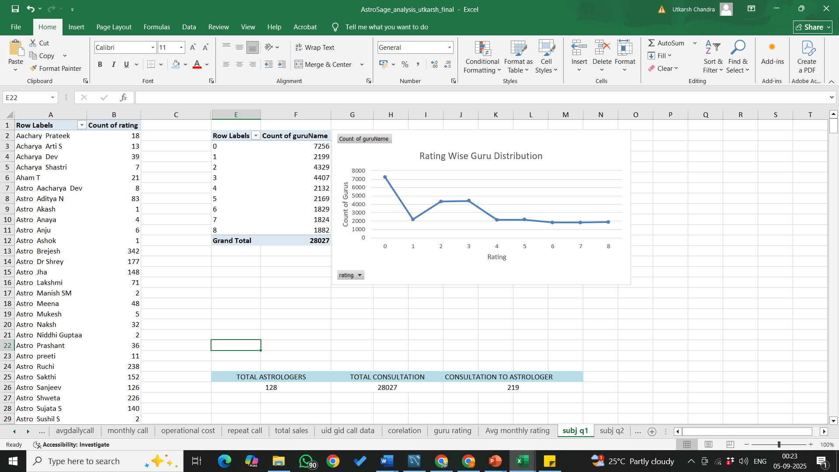

The table highlights the number of astrologers compared with the total calls received. Using the COUNTA and UNIQUE functions, we derived the astrologer count, and by comparing it with total calls, we got the ratio of calls per astrologer. From this, it’s quite clear that hiring more astrologers is not an urgent requirement.
The area chart showing the average ratings of astrologers points to a visible inconsistency. Ratings fluctuate a lot, which signals the need for better training and skill development. This would directly improve the quality of consultations and boost ratings.

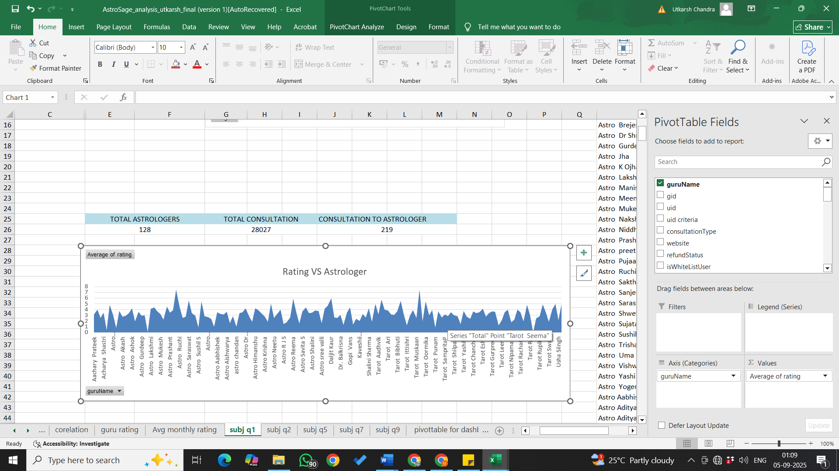

The pie chart illustrating call status distribution makes another insight obvious:
there’s a need for technological improvements to increase the rate of completed calls. Upgrading technology would directly contribute to customer satisfaction. What are the potential risks of each investment option (hiring, training, technology upgrades), and how can they be mitigated?

Risks & Mitigation for Each Investment Option
1. Hiring:
Hiring new astrologers is a long and resource-intensive process. Recruitment needs to ensure candidates are genuinely skilled, and proper training has to be arranged. If a candidate backs out at the last moment, all the effort and resources invested go to waste, forcing the team to start again. Looking at the pivot tables and visualizations, it’s clear that the current team of consultants is sufficient to handle calls.
Mitigation:
This risk can be reduced by offering referral bonuses to high-performing astrologers who bring in skilled candidates. This not only eases hiring but also improves the overall quality of consultants.

2. Training
Training is essential for improving consultation quality and customer satisfaction. However, introducing a new training suite comes with challenges: coordinating availability of all consultants, creating new strategies, and making a significant financial investment. This process can be both time-consuming and costly.
Mitigation:
Instead of going for heavy investments, the organization can arrange guest workshops, start reward programs for top-rated consultants, and share recordings of excellent consultations with the team. These small but impactful initiatives can encourage learning at a much lower cost.

3. Technological Upgrades
Upgrading technology is critical for smoother operations and better customer experience. However, it carries risks such as high investment requirements, need for technical support staff, chances of system failures, and possible difficulties astrologers may face in adapting to new tools.
Mitigation:
These risks can be addressed by introducing a new CRM system to strengthen customer support, and by gradually creating a workforce environment that makes adaptation to new technology smoother and more comfortable for astrologers.

Q.2 What are the potential risks of each investment option (hiring, training, technology upgrades), and how can they be mitigated? Name the chart/spreadsheet function you will use for solving the problem.
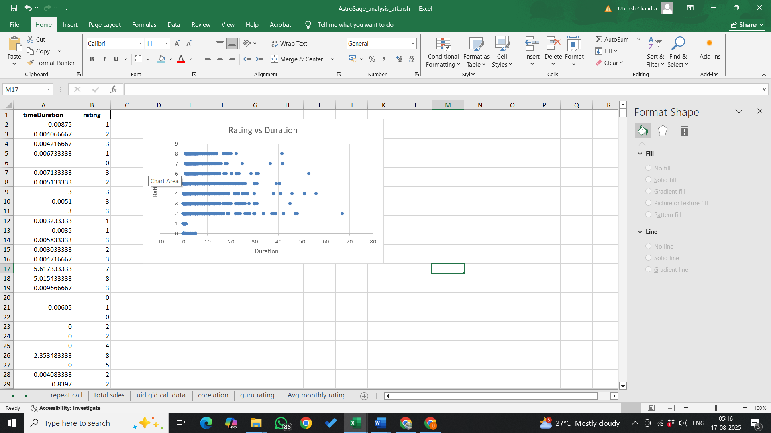
Approach:
- Used a SCATTER PLOT to visualize the relationship between call duration and rating, comparing variability and trends across data points.
Insights:
- Wide variability in call durations across all rating levels.
- No strong trend or correlation: higher/lower durations do not consistently correspond to higher/lower ratings.
- Some ratings display large spreads in call duration, highlighting inconsistent customer experiences.
- Suggests that improvements in one metric (duration or rating) may not have a direct effect on the other.
Risks and Mitigation Strategies:
- Hiring
  - Risks:
    - High turnover due to job dissatisfaction/stress.
    - Escalating recruitment costs with no guarantee of long-term retention.
    - New hires may not match required skills.
  - Mitigation:
    - Use structured recruitment processes with cultural fit assessments.
    - Offer competitive pay and a supportive environment.
    - Leverage analytics tools (e.g., Excel candidate assessment tracking) to gauge suitability.
- Training
  - Risks:
    - High training costs with no assured improvement.
    - Operations may be disrupted during training periods.
    - Training content may not suit all skill levels.
  - Mitigation:
    - Design flexible, role-specific modules (use e-learning and microlearning where possible).
    - Schedule sessions off-peak to avoid disruptions.
    - Regularly update content using employee feedback and performance data analytics (AVERAGE, COUNTIF).
- Technology Upgrades
  - Risks:
    - Significant upfront investment.
    - Staff may resist or struggle to adopt new systems.
    - Possible operational downtime or technical failures during rollout.
  - Mitigation:
    - Perform cost-benefit analysis for each upgrade (SUM, NPV for ROI calculations).
    - Provide hands-on training and accessible technical support.
    - Choose reliable vendors and prepare fallback/contingency plans for implementation issues.

Q.3. How does AstroSage's call center performance compare to AstroGuru's average call volume, customer satisfaction, and agent performance? Will you use any aggregation function or a visualization here to solve the problem?
Solution:
Comparison of AstroSage and AstroGuru
AstroSage:
- Handles very high user traffic with 1.2+ million daily active users.
- Call completion rate is around 56.41%, and only 23% of issues get resolved via phone calls, showing pressure on infrastructure.
- Customer satisfaction is mixed; high call durations do not necessarily lead to better ratings.
- Agent performance varies significantly, with inconsistencies in efficiency and quality of engagement.
AstroGuru:
- Average call volume data is not publicly available, but the platform operates on a smaller scale compared to AstroSage.
- Claims 98% customer satisfaction, though this figure is likely a marketing claim and not independently audited.
- Agent performance in smaller call centers is generally easier to monitor and control, but scalability is limited compared to AstroSage.

Use of Aggregation Functions and Visualization
To solve such a comparison problem using data:
- Aggregation Functions:
  - AVERAGE → to calculate average call duration, average rating.
  - MAX and MIN → to identify best and worst performing agents.
  - COUNT → to measure total calls handled per agent.
  - CORREL → to check relationship between call duration and ratings.
- Visualization:
  - Scatter Plot → to show relationship between call duration and satisfaction.
  - Bar/Column Chart → to compare agent performance (average rating, average duration).
  - PivotTables with Aggregates → to summarize and compare call center metrics at scale.
Conclusion:
AstroSage, despite its massive call volume and reach, struggles with low call completion rates and inconsistent agent performance, which weakens customer satisfaction, whereas AstroGuru, operating on a smaller scale, maintains tighter quality control but faces limits in scalability; thus, AstroSage highlights the challenges of scale, while AstroGuru highlights the challenges of growth, and their comparison can be effectively analyzed using aggregation functions such as AVERAGE, MAX, MIN, and CORREL, alongside visualizations like scatter plots, bar charts, and pivot tables.

Q.4 How can the call center improve its handling of peak call periods to ensure high customer satisfaction? Mention the functionality you will use for giving the suggestions, will it be any aggregated function or a visualization.
As visible from the above chart we have a very variable flow of peak hours so the company can communicate with consultants and make an effective workflow by monitoring the availability of them and make batches, for different hours of the day and allow the customer to choose among the available one's. Moreover, restrict each consultant on defined number of sessions only.

Here we can clearly see from the graph where vertical axis represents the peak hours and horizontal axis represents the total calls.

How the call center can improve handling of morning peak hours
- Staff Allocation & Rostering
  - Schedule more astrologers specifically in the morning hours (8 AM–12 PM).
  - Reduce the number of astrologers in late-night hours where calls are minimal.
  - Functionality used: COUNT aggregation in PivotTable (calls grouped by hour) to find exact peak windows.
- Queue Management during Morning Rush
  - Implement callback options if the queue is long.
  - Use automated responses to keep customers engaged until an astrologer is free.
  - Functionality used: Visualization (Bar/Line chart) showing hourly load to pinpoint bottlenecks.
- Training Astrologers for Quick Response
  - Provide efficient consultation techniques for high-demand slots.
  - Reward those who handle the most calls effectively during peak hours.
  - Functionality used: PivotChart comparing calls per hour vs. ratings.
- Technology Upgrades
  - Use a smart CRM auto-routing system so calls are evenly distributed among astrologers in busy hours.
  - Functionality used: Combination chart (Completed Calls vs. Dropped Calls by hour).

Q. 5 Based on historical data, what strategic initiatives should be prioritized to improve efficiency and customer satisfaction?
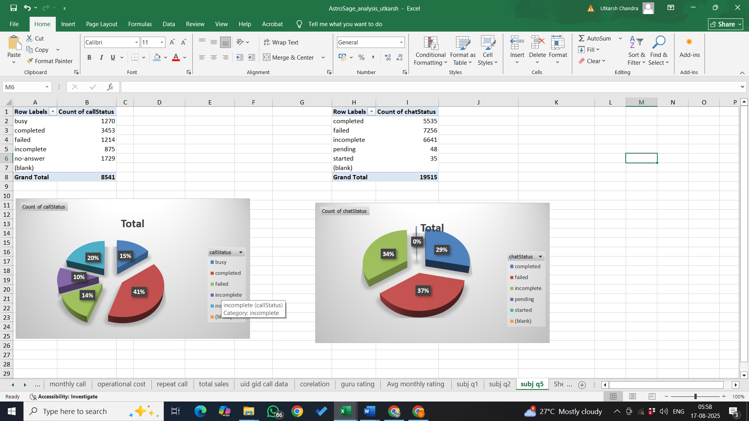
Approach:
- Created pie charts to visually represent distribution of call and chat outcomes.
- Used visual data to pinpoint operational inefficiencies and highlight areas requiring technology or process improvements.
- Just 41% of calls are completed successfully; the remaining 59% are either missed (20% no-answer), busy (15%), failed (14%), or incomplete (10%).
- For chat interactions, only 37% complete successfully; a high 37% fail, and a significant share remains incomplete or pending (26%).
- High percentages of failed or incomplete engagements highlight major system/process issues:
Possible causes: insufficient staffing, outdated tech infrastructure, inefficient routing, lack of automated handling.
- Current call/chat center competency is below industry benchmarks for customer engagement completion rates.

- Operational Efficiency
- Optimize staffing by aligning agent schedules to peak hours using historical call data and COUNTIF/SUM analysis to forecast demand.
- Introduce skill-based routing with an automated system, ensuring customers reach agents best equipped to resolve their issues.
- Reduce call wait times and abandonments by monitoring real-time dashboards and adjusting shifts proactively.
- Technology Integration
- Upgrade to an integrated CRM platform for unified customer data, better tracking, and seamless omnichannel interactions.
- Deploy AI-powered chatbots and virtual assistants for handling repetitive or simple inquiries, freeing agents for complex cases.
- Enable consistent, reliable customer experience across voice, chat, email, and social channels.
3. Reduce No-Answer & Pending Calls
- Implement an auto-callback feature for unanswered calls, boosting conversion and reducing customer frustration.
- Apply advanced routing to minimize transfers and shorten average resolution times.
4. Minimize Failed & Incomplete Calls
- Regularly test and upgrade network/IVR systems to prevent technical failures and call drops.
- Conduct targeted agent training on troubleshooting, objection handling, and efficient call closing techniques.
- Optimize call scripts for clarity and brevity without reducing solution quality.
Action Plan:
- Short-Term (1–2 weeks):
  - Launch auto-callback options.
  - Start agent refresher courses focused on call and chat handling.
- Mid-Term (1 month):
  - Begin dynamic shift scheduling based on recent volume data.
  - Address and resolve known technical issues causing disruptions.
- Long-Term (3+ months):
  - Implement AI-driven routing and workflow automation.
  - Consider gamified performance incentives to further improve agent engagement and results.
Overall, these initiatives—supported by aggregation (e.g., COUNTIF, AVERAGE) and real-time dashboard visualizations—will directly target root causes of inefficiency and enhance both service quality and customer satisfaction.

Q.6. What can be the key factors contributing to high customer satisfaction scores, and how can these be leveraged to improve overall performance? What is the basis for the suggestions? And mention how you decided if the satisfaction score affects the ratings.

Key Observations:
  - Failed chats have the highest count (~7000), but their max rating is only 1, indicating dissatisfaction and a critical failure point.
  - Completed chats have a relatively high count (~5000) and a moderate max rating of 5, showing that while completions are happening, there is room for improvement.
  - Other statuses (e.g., pending, started) show negligible counts, suggesting minimal impact but an opportunity for refinement.
  - Implication: The high failure rate reflects inefficiencies in chat processes, which could damage customer satisfaction and trust.
Call Service:
- Key Observations:
  - Completed calls have the highest count (~3500) and a consistent max rating of 5, highlighting successful resolution and satisfaction.
  - No-answer calls have a significant count (~2000) but a max rating of 5, implying unresolved customer queries.
  - Failed and incomplete calls also contribute to inefficiencies in operations.
- Implication: The call service performs reasonably well in completing interactions but needs improvement in handling unanswered and failed calls.
Recommendations:
To address these issues and improve overall efficiency and customer satisfaction:
CHAT Service:
- Reduce Failures:
  - Conduct root-cause analysis to understand why chats fail (e.g., technical glitches or agent unavailability).
  - Invest in chatbot AI to handle simple queries effectively and reduce pressure on human agents.
  - Train agents to manage conversations more efficiently.
- Enhance Completion Rates:
  - Monitor completed chats to identify patterns leading to success and replicate those strategies.
  - Simplify chat workflows to make processes faster and more user-friendly.
CALL Service:
- Address Unanswered Calls:
  - Introduce call-back options to minimize customer wait times during high-demand periods.
  - Use predictive analytics to align agent availability with peak call times.
- Improve Failed and Incomplete Calls:
  - Provide regular training for agents on resolving complex queries more effectively.
  - Streamline call routing mechanisms to connect customers with the most suitable agents.
Cross-Service Initiatives:
- Focus on Technology:
  - Upgrade communication tools to handle higher volumes with fewer disruptions.
  - Implement real-time monitoring dashboards for both chat and call services.
- Customer Feedback Integration:
  - Actively seek feedback from customers after interactions to pinpoint areas for improvement.
  - Use these insights to refine processes and enhance service delivery.
Conclusion:
Prioritize reducing failure rates in CHAT services and unanswered calls in CALL services while leveraging technology and employee training to optimize performance. By addressing these pain points strategically, you can significantly boost operational efficiency and customer satisfaction.

Q. 7. How should the call center balance the workload among agents to ensure optimal performance and avoid burnout? Mention your approach and spreadsheet function for the answer.

Insights from Chart
- The count of consultation type (orange line) shows that some agents handle much higher call volumes compared to others.
- The average rating (blue line) remains fairly stable, but if call loads are unevenly distributed, even high-rated agents risk burnout.
- Morning hours seem to have peak call loads, which means agents available in that slot bear more stress.
To ensure optimal performance and avoid burnout, the call center should adopt the following approach:
- Workload Balancing: Calls should be allocated on a rotational or round-robin basis so that no single agent is overloaded. By distributing incoming calls more evenly, the stress levels across agents can be balanced.
- Peak-Hour Staffing: Since the maximum call traffic occurs during morning hours, additional agents should be scheduled during these slots. This prevents overloading a small set of agents during high-demand periods.
- Performance-Aware Allocation: While high-rated agents are valuable for handling complex or sensitive queries, they should not always receive the maximum volume. Performance metrics like average rating should guide task allocation—high performers handle priority calls, but workload should remain evenly spread.
- Dynamic Monitoring: Using live dashboards and periodic review of workload data (like the chart created), managers can identify agents with consistently higher call counts and adjust routing policies accordingly.
- Breaks and Rotation: Regular breaks and shift rotations should be mandated, particularly for agents in high-traffic slots, to maintain both mental health and service quality.

Q.8. What new technologies or tools could be implemented to enhance call center operations and customer service?
New technologies/tools for enhancing call center operations and customer service.
In today’s fast-paced world, customers expect quick, smooth, and personalized service. Call centers are the frontline of any company’s relationship with its customers, and the right tools can make a huge difference. Modern technologies not only make agents’ lives easier but also ensure customers feel heard, valued, and satisfied. By adopting smart solutions, call centers can handle more queries efficiently, reduce mistakes, and create happier customers.
Technologies and Tools to Make Call Centers Smarter and Customer-Friendly:
- Advanced CRM Systems
  - Think of this as a digital memory for your team. It keeps track of every customer interaction, complaint, and query.
  - Agents can quickly see the customer’s history and provide a personal touch.
  - Why it matters: Customers don’t like repeating themselves, and agents can solve problems faster.
- AI-Powered Chatbots & Virtual Assistants
  - Bots can answer simple questions instantly, like account info or order status, any time of day.
  - Complex issues are passed to human agents, so no one feels ignored.
  - Why it matters: Reduces waiting time, lets agents focus on tricky problems, and keeps customers happy around the clock.
- Smart IVR Systems
  - These are the automated menus you hear when you call. Modern IVRs understand your voice or choice and direct you to the right agent quickly.
  - Why it matters: Fewer transfers, less waiting, and a smoother experience.
- Predictive Analytics
  - By looking at past call data, you can predict when calls will spike and what customers usually ask.
  - Why it matters: Helps schedule the right number of agents, so no one is left waiting.
- Omnichannel Platforms
  - Customers reach out through calls, emails, chat, social media, or apps. Omnichannel tools bring all these interactions into one view for the agent.
  - Why it matters: A customer’s question gets answered quickly and consistently, no matter the channel.
- Quality Monitoring & Speech Analytics
  - Tracks how agents talk to customers, the tone, and sentiment.
  - Why it matters: Helps spot training needs and ensures customers always get polite, helpful service.
- Cloud-Based Call Centers
  - Agents can work from anywhere, and the system grows easily as the business expands.
  - Why it matters: More flexibility, less cost, and seamless service even during busy times.
- Workforce Management Tools
  - Helps plan shifts and workloads so that calls are always answered on time.
  - Why it matters: Keeps agents from getting overwhelmed and customers from getting frustrated.
- Customer Feedback Tools
  - Simple surveys after a call or chat to know what went well and what didn’t.
  - Why it matters: Direct feedback shows where improvements are needed, making service better over time.
Conclusion:
Technology is more than just fancy software—it’s a way to make customers feel valued and agents feel empowered. By combining smart tools like AI chatbots, CRMs, omnichannel platforms, and analytics, call centers can work faster, smoother, and smarter. The end result? Happier customers, confident agents, and a business that thrives in today’s competitive world.

Q.9. What metrics should be included in the final dashboard to comprehensively view call center performance and guide investment decisions?

To provide a complete and business-focused view of the call center’s performance, I designed a single-page consolidated dashboard that displays all key metrics together. This format helps decision-makers quickly assess trends without navigating across multiple pages.
The dashboard was structured with clear sections for KPIs, operational charts, platform insights, and agent evaluations - allowing stakeholders to make well-informed investment decisions at a glance.
The final dashboard includes the following critical metrics and charts:

1. website distribution
2. Revenue generated by category type
3. Call distribution over hrs
4. Day by day call volume
5. Call status distribution
6. Chat status distribution
7. Rating wise guru distribution
8. Rating wise customer distribution
9. Top 10 guru by Rating

Insights:
- Call volume patterns show strong user engagement during morning and afternoon hours.
- Revenue is primarily driven by Chat and Call consultations, indicating demand for both synchronous and asynchronous services.
- Website usage skews heavily toward the 'app' and 'dashboard', while Gurucool is minimal.
- Top agents by rating and volume are not always the same, helping separate performance from popularity.
- User ratings skew towards mid-to-high values, but distribution varies agent-wise.

Q.10. How would you allocate a 1 crore rupee investment to optimize operational efficiency, enhance customer satisfaction, and boost profitability, and what analysis-based recommendations would you offer to support this?
[you have to give bullet pointers to answer this question]
Investing ₹1 crore in a call center requires a careful balance between improving operational efficiency, enhancing customer satisfaction, and boosting profitability. A well-thought-out allocation ensures that technology, people, and processes work together to create a seamless customer experience while maximizing returns. The following plan is based on practical insights and industry trends.

Proposed Allocation of ₹1 Crore:
- Technology & Infrastructure – ₹35 lakh
  - Upgrade the call management system to a modern CRM (Customer Relationship Management) platform for tracking all customer interactions efficiently.
  - Introduce AI-powered features like chatbots for simple queries and intelligent call routing to connect customers to the right agent faster.
  - Enhance hardware quality: invest in high-quality headsets, computers, and stable internet to reduce downtime and call disruptions.
  - Set up cloud-based storage and security systems to safely manage customer data.
Impact: Improved technology reduces waiting times, increases first-call resolution, and allows agents to handle more calls effectively.
- Employee Training & Development – ₹20 lakh
  - Conduct training programs for agents on customer communication, empathy, problem-solving, and upselling techniques.
  - Train supervisors to monitor performance and provide constructive feedback.
  - Encourage periodic workshops to keep agents updated on new tools, products, or services.
Impact: Well-trained agents resolve queries faster, improve customer satisfaction scores, and reduce errors or repeated calls.
- Process Optimization – ₹15 lakh
  - Map out the current call handling workflow to identify bottlenecks and repetitive tasks.
  - Simplify data entry processes and remove unnecessary steps in handling customer queries.
  - Introduce standardized scripts or guidelines for common issues to ensure consistency and reduce confusion.
Impact: Streamlined processes save time, reduce mistakes, and allow agents to focus on solving customer problems rather than administrative tasks.
- Employee Engagement & Incentives – ₹10 lakh
  - Launch performance-based bonuses for top-performing agents based on KPIs like calls handled, customer feedback, and resolution speed.
  - Organize recognition programs, team-building events, and wellness initiatives to improve morale.
  - Encourage a positive work environment to reduce employee turnover.
Impact: Motivated employees are more productive, create a better customer experience, and reduce costs associated with hiring and training new staff.
- Customer Experience Enhancement – ₹20 lakh
  - Implement tools to collect customer feedback via surveys or ratings after each call.
  - Personalize interactions based on customer data to provide a tailored service experience.
  - Introduce proactive communication like follow-ups, reminders, or personalized offers.
Impact: Higher customer satisfaction leads to repeat business, referrals, and ultimately increased profitability.

Recommendations & Supporting Analysis:
- Track Key Metrics: Monitor Average Handle Time (AHT), First Call Resolution (FCR), customer satisfaction (CSAT), and call abandonment rates to identify areas for improvement.
- Data-Driven Decisions: Use CRM and analytics to understand peak call times, common issues, and agent performance.
- Balanced Investment: Ensure spending is spread across technology, people, and processes to create sustainable improvements rather than focusing on just one area.
- Plan for Growth: Select scalable solutions so that as call volume grows, the system and processes can handle increased demand without additional heavy investment.

Conclusion:
A strategically allocated ₹1 crore investment focusing on technology, employee development, process simplification, and customer experience can significantly enhance operational efficiency, customer satisfaction, and profitability. By continuously monitoring performance metrics and making data-informed adjustments, the call center can achieve sustainable growth and long-term success.

